Kashif Ali

BSAI 3-D

239

Question # 1
What I did in the code:
- This program runs the A* search algorithm on a small weighted graph and tries to find a route from the start node S to the goal node G.
- It keeps its frontier in a priority queue (heapq) sorted by f = g + h, where g is the real cost travelled so far and h is the heuristic guess of the cost remaining to the goal.
- At every step it removes the node with the smallest f. If that node has been expanded before it is skipped, otherwise it is marked as visited and its g, h and f values are printed.
- Then it goes through the unvisited neighbours of that node. For each one it works out the new g (current g plus the edge cost) and pushes (new f, new g, neighbour) into the frontier.
- The loop is limited to 3 iterations (range(3)), so instead of running until the goal is reached, it shows only the first three expansions and the frontier after each of them.
Code explanation:
- graph holds the graph as a dictionary of (neighbour, cost) pairs, and h holds the heuristic value of every node. The queue starts as pq = [(6, 0, 'S')], which means the start node S with f = 6 and g = 0.
- heapq.heappop(pq) takes out the entry with the lowest f. The line if node in visited: continue ignores any node that was already expanded.
- visited.add(node) records the node as expanded, and the print statement displays its g (cost so far), h (heuristic) and f (g + h).
- The loop for nxt, cost in graph[node] visits each unvisited neighbour, calculates ng = g + cost, and uses heapq.heappush to insert (ng + h[nxt], ng, nxt) into the queue.
- for step in range(3) stops the run after three expansions, and print("Frontier:", pq) shows what is in the queue after each one, so you can follow how A* picks its next node.

Output

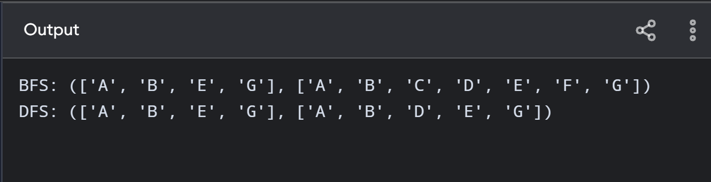

Question # 2
What I did in the code:
- I wrote one function, search(astar), which runs either A* Search (astar=True) or Uniform Cost Search (astar=False) on the identical graph, so the two methods can be compared fairly.
- Each queue entry is (priority, g, node, path). The priority is f = g + h for A* and just g for UCS. This is the only thing that separates the two algorithms.
- A dictionary called best stores the lowest cost found so far for each node. A neighbour is added to the queue only when its new cost is smaller (ng < best.get(nxt, inf)), and old queue entries are ignored with the check if g != best[node].
- The list expanded keeps the order in which nodes are expanded. When G is taken out of the queue, the function prints the final path, its cost and that list, and then stops.
- Both algorithms return the same optimal path, [‘S’, ‘A’, ‘C’, ‘G’], with cost 6. A* expands fewer nodes (S, A, C), while UCS expands more (S, A, C, B, D). This shows how the heuristic makes the search more efficient.
Code explanation:
- graph and h contain the weighted graph and the heuristic estimates. search(astar) is a single function that behaves as A* when given True and as Uniform Cost Search when given False.
- pq begins with node S. Every entry has the form (priority, g, node, path). best records the cheapest known cost to each node, and expanded records the order of expansion.
- In the while pq loop, heapq.heappop removes the entry with the lowest priority. The condition if g != best[node]: continue throws away outdated entries whose cost is worse.
- If the removed node is ‘G’, the function prints the path, its cost and the expanded nodes, and ends. Otherwise the node is added to expanded and its neighbours are examined.
- For each neighbour, ng = g + cost is calculated. If it is lower than the best known cost, best is updated and the neighbour is pushed with priority ng + h[nxt] for A*, or just ng for UCS. The final two lines run both searches and print the results so they can be compared.

Question # 3
What I did in the code:
- The code runs A* Search on the same graph again, this time to test what happens when one heuristic value is altered. It contains the graph, the heuristic values h, and an astar() function that prints the path found and its cost.
- astar() orders its priority queue by f = g + h. The dictionary best keeps the cheapest known cost to each node, so worse or outdated entries get skipped.
- The first run uses the original heuristic, which is admissible (it never overestimates). A* finds the optimal path [‘S’, ‘A’, ‘C’, ‘G’] with cost 6.
- Next, I set h['C'] = 10, although the real remaining cost from C is only 3, so the heuristic now overestimates. Node C appears too costly (f = 13), so A* passes it over and goes through D instead.
- This produces a worse path, [‘S’, ‘A’, ‘D’, ‘G’], with cost 8 instead of 6. The last three prints show the purpose of the experiment: an inadmissible heuristic can make A* return a solution that is not optimal.
Code explanation:
- The program runs A* Search two times on the same graph to see how changing a single heuristic value affects the outcome. The astar() function prints the path it finds and the total cost.
- astar() sorts its priority queue by f = g + h. The dictionary best stores the cheapest known cost to each node, and the check g != best[node] ignores stale queue entries.
- In the first run the heuristic is admissible, which means it never guesses more than the real cost to the goal. A* returns the optimal path [‘S’, ‘A’, ‘C’, ‘G’] with cost 6.
- Then h['C'] = 10 turns the heuristic of C into an overestimate, since the real remaining cost from C to G is just 3. This makes C look expensive (f = 13), so A* tries B and D first and reaches G through D.
- The second run therefore returns [‘S’, ‘A’, ‘D’, ‘G’] with cost 8, which is worse than 6. This proves that A* is guaranteed to find the optimal path only when the heuristic is admissible.

